Lab 4 – Url filtering and override

Purpose: to filter certain category of websites and block them. Then make it possible to enter a password to override the block.

Background: This is the first ever time we used a function of the firewall to do something practical. The goal was to find documentation online that could help us do that.

Lab Summary:

Step 1: go to network > url filtering and click the default to see the categories of websites that are already blocked.

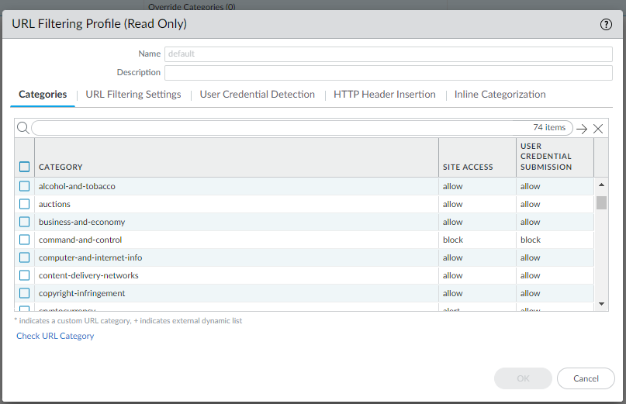

Step 2: Click add. Name the profile anything and pick a category to block. Under site access, select override for that category and under user credential submission select allow.

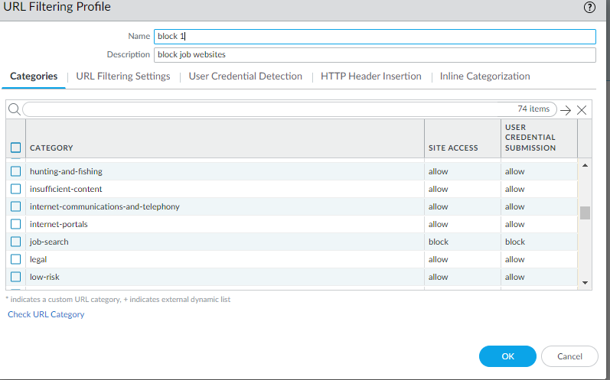

Step 3: go to policies > security > and go to internet outgoing. Go to actions and under url filtering, select the profile you just created. Click ok.

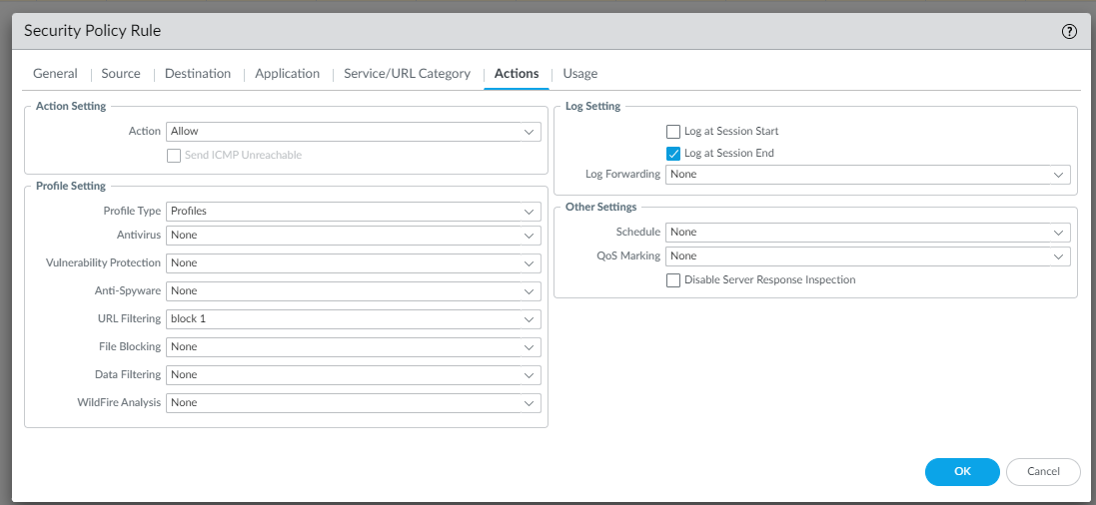

Step 4: go to device > certificates. Click generate.



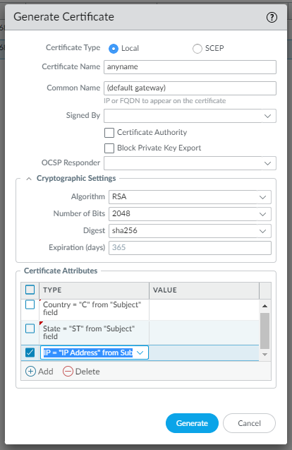

Use these to make your certificate

Step 5: go to network > interface management. Click add.

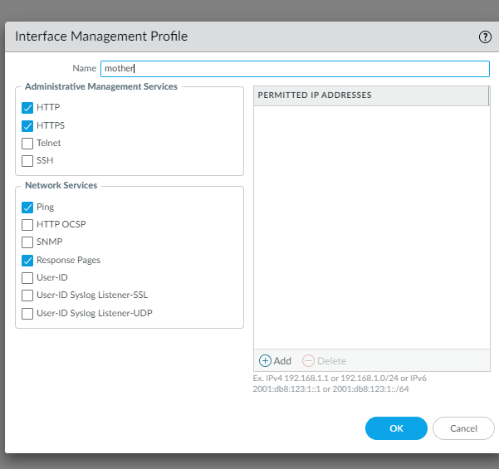

Use the following to setup management profile

Step 6: go to network > interfaces and ethernet. On your layer 3 interface, go to advanced. Apply the management interface that you just created to management profile

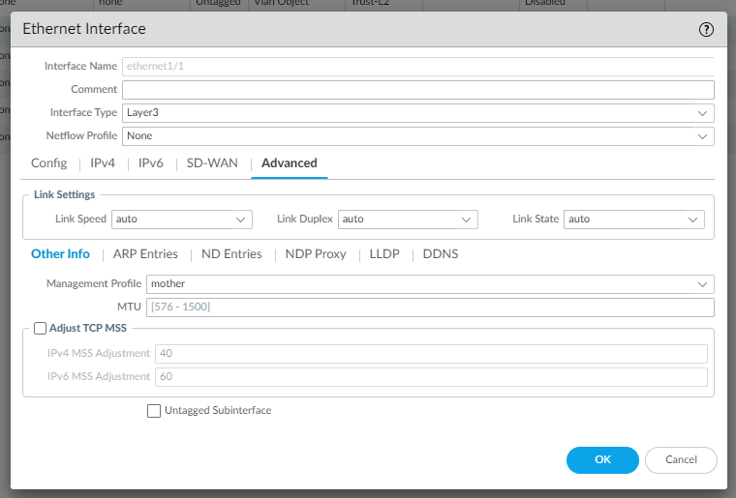

Problems: For a very long time, we tried going to device > response pages and tried configuring override on URL filtering Continue and Override Page. This was a massive waste of time because there is no way to configure anything on this page, you can only use what is preconfigured.

Conclusion: This lab gave us a basic idea about one of the most powerful and useful functions of firewall. Even if this was a very basic configuration, i